**Assignment 2**

**Problem Statement :-**

Consider a movie database in which data is recorded about the movie industry. The date requirements are summarised as follows –

* Each movie is identified by title and year of release. Each has a production ­company, and each is classified under one or more types (such as horror, action, drama, comedy). Each movie has one or more directors and one or more actors appear in it. Each movie also has a plot outline. At last each movie has zero or more quotable quotes, each of which is spoken by a particular actor appearing in the movie.
* Actors are identified by name, DOB and appearing in one or more movies. Each actor has a role in the movie.
* Directors are also identified by name, DOB and can also direct one or more movies, it is possible for one director to act in movie.
* Production companies are identified by name and each has an address. A production company produces one or more movies.

**Report:**

A report on the movie (with detailed information) generated by a specific production Company sorted in terms of movie types.

**---: SOLUTION :---**

**Section (A): Database Design**

**(A.1) ER Diagram Design :-**

To solve the problem, first we design the ER diagram. For creating ER diagram, we are following some steps –

**Step 1:** Finding the Entity sets

After reading that statement, we found that there are 3 entity sets available.

* **Movie**
* **Actor**
* **Director**
* **Production**

**Step 2:** Finding the Relations between Entity sets

+

* Between **Actor** and **Movie** there is a relation named “**Act in**”.
* Between **Movie** and **Actor** there is a relation named “**Quote given**”.
* Between **Director** and **Movie** there is a relation named “**Direct**”.
* Between **Production** and **Movie** there is a relation named “**Produce**”.

**Step 3:** Finding Cardinality sets

* The relation “**Act in**” between **Actor** and **Movie** has ‘**many to many**’ relationship.
* The relation “**Quote given**” between **Movie** and **Actor** has ‘**many to many**’ relationship.
* The relation “**Directed**” between **Movie** and **Director** has ‘**many to many**’ relationship.
* The relation “**Produce**” between **Production** and **Movie** has ‘**one to many**’ relationship.

**Step 4:** Finding the Attribute Sets

* **Movie:** m_id, title, yor, length, plot, type.
* **Actor:** a_id, aname, dob, movie_no, gender.
* **Director:** d_id, dname, dob.
* **Production:** p_id, pname, address.

**Step 5:** ER Diagram Draw

**Actor**

**m**

**m**

**Quote given**

**Act in**

**m**

**m**

**Movie**

**m**

**Produce**

**m**

**Directed**

**1**

**Production**

**m**

**Director**

**Fig:- F2.1**

**(A.2) Schema Design :-**

After creating the ER Diagram, now we have to create the schemas. Now for creating the schemas we have to take some assumptions form the ER diagram.

**(A.2.1) Assumptions form ER Diagram (Fig F2.1) :-**

1. In the relation “**Act in**” to establish the ‘**many to many**’ relationship we create another entity called **Acting** and take ‘a_id’ as foreign key from **Actor** entity and ‘m_id’ as foreign key from **Movie** entity and make them composite primary key into the **Acting** entity. In this entity another attribute is added named by ‘role’.
2. For the relation “**Quote given**” of ‘**many to many**’we create another entity called **Quotes** where ‘m_id’ as foreign key from the entity **Movie** and ‘a­_id’ as foreign key from **Actor** and make them both as a composite primary key of **Quotes**. In this entity another attribute is added named by ‘quote_text’.
3. For the relation “**Directed**” of ‘**many to many**’ relationship we create another entity set called **Directed** and ‘m_id’ as foreign key from **Movie** entity and ‘d_id’ as foreign key from **Director** entity and make them both a composite primary key of that entity. In this entity another attribute is added named by ‘act’.
4. For the relation “**Produce**” of ‘**one to many**’ relationship we take ‘p_id’ from **Production** entity and set it as foreign key into the **Movie** entity.
5. In the **Movie** entity the ‘type’ attribute is multivalued attribute, so we create another entity called **Movie_Type** with the ‘m_id’ of the **Movie** entity as foreign key and the ‘type’ attribute and make them composite primary key.

**(A.2.2) Schemas :-**

* **Movie** ( m_id, title, yor, length, plot, p_id )
* **Actor** ( a_id, aname, dob, movie_no, gender )
* **Director** ( d_id, dname, dob )
* **Production** ( p_id, pname, address )
* **Acting** ( a_id, m_id, role )
* **Quote** ( m_id, a_id, quote_text )
* **Directed** ( d_id, m_id, act )
* **Movie_Type** ( m_id, type )

Now we get our all schemas and it seems that all schemas are normalised up to **3NF**. We don’t normalise it further.

**(A.3) Source Code for the Database :-**

All schemas are designed and normalised, now we create those schemas into the mysql database.

**(A.3.1) Table Creation :-**

**Production Table**

MariaDB [assignment2]> create table production(p_id varchar(4) primary key,pname varchar(20), address varchar(20));

Query OK, 0 rows affected (0.239 sec)

MariaDB [assignment2]> desc production;

**| Field | Type | Null | Key | Default | Extra |**

| p_id | varchar(4) | NO | PRI | NULL | |

| pname | varchar(20) | YES | | NULL | |

| address | varchar(20) | YES | | NULL | |

3 rows in set (0.053 sec)

**Director Table**

MariaDB [assignment2]> create table director(d_id varchar(4) primary key,dname varchar(15),dob date);

Query OK, 0 rows affected (0.239 sec)

MariaDB [assignment2]> desc director;

**| Field | Type | Null | Key | Default | Extra |**

| d_id | varchar(4) | NO | PRI | NULL | |

| dname | varchar(15) | YES | | NULL | |

| dob | date | YES | | NULL | |

3 rows in set (0.030 sec)

**Actor Table**

MariaDB [assignment2]> create table actor(a_id varchar(4) primary key,aname varchar(15),gender varchar(1),dob date,movie_no int(4));

Query OK, 0 rows affected (0.307 sec)

MariaDB [assignment2]> desc actor;

**| Field | Type | Null | Key | Default | Extra |**

| a_id | varchar(4) | NO | PRI | NULL | |

| aname | varchar(15) | YES | | NULL | |

**| Field | Type | Null | Key | Default | Extra |**

| gender | varchar(1) | YES | | NULL | |

| dob | date | YES | | NULL | |

| movie_no | int(4) | YES | | NULL | |

5 rows in set (0.036 sec)

**Movie Table**

MariaDB [assignment2]> create table movie(m_id varchar(4) primary key,title varchar(15),yor date,length int(3),plot varchar(15),p_id varchar(4) references production(p_id));

Query OK, 0 rows affected (0.580 sec)

MariaDB [assignment2]> desc movie;

**| Field | Type | Null | Key | Default | Extra |**

| m_id | varchar(4) | NO | PRI | NULL | |

| title | varchar(15) | YES | | NULL | |

| yor | date | YES | | NULL | |

| length | int(3) | YES | | NULL | |

| plot | varchar(15) | YES | | NULL | |

| p_id | varchar(4) | YES | | NULL | |

6 rows in set (0.031 sec)

**Movie_Type Table**

MariaDB [assignment2]> create table movie_type(m_id varchar(4) references movie(m_id),type varchar(10),primary key(m_id,type));

Query OK, 0 rows affected (0.652 sec)

MariaDB [assignment2]> desc movie_type;

**| Field | Type | Null | Key | Default | Extra |**

| m_id | varchar(4) | NO | PRI | NULL | |

| type | varchar(10) | NO | PRI | NULL | |

2 rows in set (0.035 sec)

**Quote Table**

MariaDB [assignment2]> create table quote(m_id varchar(4) references movie(m_id),quote_text varchar(20),a_id varchar(4) references actor(a_id),primary key(m_id,a_id));

Query OK, 0 rows affected (0.273 sec)

MariaDB [assignment2]> desc quote;

**| Field | Type | Null | Key | Default | Extra |**

| m_id | varchar(4) | NO | PRI | NULL | |

| quote_text | varchar(20) | YES | | NULL | |

**| Field | Type | Null | Key | Default | Extra |**

| a_id | varchar(4) | NO | PRI | NULL | |

3 rows in set (0.027 sec)

**Acting Table**

MariaDB [assignment2]> create table acting(m_id varchar(4) references movie(m_id),a_id varchar(4) references actor(a_id),role varchar(10),primary key(m_id,a_id));

Query OK, 0 rows affected (0.289 sec)

MariaDB [assignment2]> desc acting;

**| Field | Type | Null | Key | Default | Extra |**

| m_id | varchar(4) | NO | PRI | NULL | |

| a_id | varchar(4) | NO | PRI | NULL | |

| role | varchar(10) | YES | | NULL | |

3 rows in set (0.035 sec)

**Direction Table**

MariaDB [assignment2]> create table direction(d_id varchar(4) references director(d_id),m_id varchar(4) references movie(m_id),act varchar(1),primary key(d_id,m_id));

Query OK, 0 rows affected (0.543 sec)

MariaDB [assignment2]> desc direction;

**| Field | Type | Null | Key | Default | Extra |**

| d_id | varchar(4) | NO | PRI | NULL | |

| m_id | varchar(4) | NO | PRI | NULL | |

| act | varchar(1) | YES | | NULL | |

3 rows in set (0.032 sec)

**Section (B): Front-end Design**

After the table creation and record insertion we have to design the Web page and we use PHP for creating the server side connection with the data base.

**(B.1) Web Page Source Code :-**

**Code of the ‘connection.php’ Page**

<?php

function connect($database_name,$user_name= "root",$password = "",$server_name = "localhost")

{

// Connection create to the database

$conn = new mysqli($server_name,$user_name,$password,$database_name);

// Connection check

if($conn->connect_error)

die("Connection Failed: ".$conn->connect_error);

return $conn;

}

?>

**Code of the ‘insert.php’ Page**

<?php

include 'connection.php';

session_start();

if (isset($_SESSION['err']) || isset($_SESSION['suc']))

{

if($_SESSION['err'] != "")

echo "<script>alert('".$_SESSION['err']."');</script>";

else

{

$_SESSION['err'] = "";

echo "<script>alert('".$_SESSION['suc']."');</script>";

}

}

session_destroy();

?>

<!DOCTYPE html>

<html>

<head>

<title>Insert Page</title>

<style>

body

{ margin: 0; padding: 0; }

button

{

display: block; width: 100%; padding: 18px;

text-decoration: none; background-color: #4CAF50; color: white;font-size: 20px;

}

tr

{ text-align: center; }

td

{ width: 50%; padding: 5px; text-align: justify-all; }

label

{ font-size: 18px; font-weight: bold; }

.header

{

padding: 30px;text-align: center; font-size: 42px; color: blue; background-color: #f1f1f1;

}

.sidediv

{

margin: 0; padding: 5px 0px 0px; width: 20%; background-color: #f1f1f1; position: fixed; height: 100%; overflow: auto;

}

.alldiv

{ margin-left:20%; padding:10px 16px 2px; display: none; }

</style>

<script>

function f(i)

{

document.getElementById("d"+i).style.display = "block";

}

function click_on(b)

{

var i;

for (i = 1; i <= 8; i++)

{

if (i == b.name)

{

document.getElementById("d"+i).style.display = "block";

}

else

{

document.getElementById("d"+i).style.display = "none";

}

}

}

</script>

</head>

<body onload="f(<?php if(isset($_SESSION['dn'])) {echo $_SESSION['dn'];} else {echo '1';} ?>)">

<!-- This is header Part -->

<div class="header">

<u>Movie DataBase</u>

</div>

<!-- This is navigation part -->

<div style="font-size: 32px;">

<div class="sidediv" style="background-color: #00FF00; text-align: center;">Table Names</div>

<div class="alldiv" style="background-color: #01f1f1; text-align: center; display: block;width: 77.6%;">

Insert The Records to the Fields

</div>

</div>

<!-- This part is for that Buttons -->

<div class="sidediv">

<button name="1" onclick="click_on(this)">Production</button>

<button name="2" onclick="click_on(this)">Movie</button>

<button name="3" onclick="click_on(this)">Actor</button>

<button name="4" onclick="click_on(this)">Director</button>

<button name="5" onclick="click_on(this)">Acting</button>

<button name="6" onclick="click_on(this)">Direction</button>

<button name="7" onclick="click_on(this)">Movie type</button>

<button name="8" onclick="click_on(this)">Quote</button>

</div>

<!-- This part is for the Production table Insertion -->

<div id="d1" class="alldiv">

<p style="font-size: 27px; text-align: center;"><u>Production table insertion Form</u></p>

<form action="production_insert.php" method="POST">

<table style="width: 100%">

<tr>

<td><label>Production House ID :</label></td>

<td><input type="text" name="pid" value=""></td>

</tr>

<tr>

<td><label>Production House Name :</label></td>

<td><input type="text" name="pname" value=""></td>

</tr>

<tr>

<td><label>Production House Address:</label></td>

<td><input type="text" name="adds" value=""></td>

</tr>

<tr>

<td style="text-align: right;"><input type="Submit" name="sb"></td>

<td style="text-align: left"><input type="Reset"></td>

</tr>

</table>

</form>

</div>

<!-- This part is for the Movie table Insertion -->

<div id="d2" class="alldiv">

<p style="font-size: 27px; text-align: center;"><u>Movie table insertion Form</u></p>

<form action="movie_insert.php" method="POST">

<table style="width: 100%">

<tr>

<td><label>Movie ID :</label></td>

<td><input type="text" name="mid" value=""></td>

</tr>

<tr>

<td><label>Movie Name :</label></td>

<td><input type="text" name="mname" value=""></td>

</tr>

<tr>

<td><label>Movie Length(Minutes) :</label></td>

<td><input type="number" name="len" value=""></td>

</tr>

<tr>

<td><label>Movie Plot :</label></td>

<td><input type="text" name="plot" value=""></td>

</tr>

<tr>

<td><label>Year of Release :</label></td>

<td><input type="date" name="yor" value=""></td>

</tr>

<tr>

<td><label>Production House ID :</label></td>

<td>

<?php

$conn = connect('assignment2');

echo "<select name = 'pid'>";

$result = $conn->query("select * from production");

while($row = $result->fetch_assoc())

{

echo "<option value = '".$row['p_id']."'>".$row['p_id']."</option>";

}

echo "</select>";

$conn->close();

?>

</td>

</tr>

<tr>

<td style="text-align: right;"><input type="Submit" name="sb"></td>

<td style="text-align: left"><input type="Reset"></td>

</tr>

</table>

</form>

</div>

<!-- This part is for the Actor table Insertion -->

<div id="d3" class="alldiv">

<p style="font-size: 27px; text-align: center;"><u>Actor table insertion Form</u></p>

<form action="actor_insert.php" method="POST">

<table style="width: 100%">

<tr>

<td><label>Actor ID :</label></td>

<td><input type="text" name="aid" value=""></td>

</tr>

<tr>

<td><label>Actor Name :</label></td>

<td><input type="text" name="aname"></td>

</tr>

<tr>

<td><label>Actor DOB :</label></td>

<td><input type="date" name="dob"></td>

</tr>

<tr>

<td><label>Gender :</label></td>

<td><input type="text" name="gender"></td>

</tr>

<tr>

<td><label>Movie Number :</label></td>

<td><input type="number" name="mv_no"></td>

</tr>

<tr>

<td style="text-align: right;"><input type="Submit" name="sb"></td>

<td style="text-align: left"><input type="Reset"></td>

</tr>

</table>

</form>

</div>

<!-- This part is for the Director table Insertion -->

<div id="d4" class="alldiv">

<p style="font-size: 27px; text-align: center;"><u>Director table insertion Form</u></p>

<form action="director_insert.php" method="POST">

<table style="width: 100%">

<tr>

<td><label>Director Id :</label></td>

<td><input type="text" name="did"></td>

</tr>

<tr>

<td><label>Director Name :</label></td>

<td><input type="text" name="dname"></td>

</tr>

<tr>

<td><label>Date of Birth :</label></td>

<td><input type="date" name="dob"></td>

</tr>

<tr>

<td style="text-align: right;"><input type="Submit" name="sb"></td>

<td style="text-align: left"><input type="Reset"></td>

</tr>

</table>

</form>

</div>

<!-- This part is for the Acting table Insertion -->

<div id="d5" class="alldiv">

<p style="font-size: 27px; text-align: center;"><u>Acting table insertion Form</u></p>

<form action="acting_insert.php" method="POST">

<table style="width: 100%">

<tr>

<td><label>Movie ID :</label></td>

<td>

<?php

$conn = connect('assignment2');

echo "<select name = 'mid'>";

$result = $conn->query("select * from movie");

while($row = $result->fetch_assoc())

{

echo "<option value = '".$row['m_id']."'>".$row['m_id']."</option>";

}

echo "</select>";

$conn->close();

?>

</td>

</tr>

<tr>

<td><label>Actor ID :</label></td>

<td>

<?php

$conn = connect('assignment2');

echo "<select name = 'aid'>";

$result = $conn->query("select * from actor");

while($row = $result->fetch_assoc())

{

echo "<option value = '".$row['a_id']."'>".$row['a_id']."</option>";

}

echo "</select>";

$conn->close();

?>

</td>

</tr>

<tr>

<td><label>Actor Role :</label></td>

<td><input type="text" name="role" value=""></td>

</tr>

<tr>

<td style="text-align: right;"><input type="Submit" name="sb"></td>

<td style="text-align: left"><input type="Reset"></td>

</tr>

</table>

</form>

</div>

<!-- This part is for the Direction table Insertion -->

<div id="d6" class="alldiv">

<p style="font-size: 27px; text-align: center;"><u>Direction table insertion Form</u></p>

<form action="direction_insert.php" method="POST">

<table style="width: 100%">

<tr>

<td><label>Movie ID :</label></td>

<td>

<?php

$conn = connect('assignment2');

echo "<select name = 'mid'>";

$result = $conn->query("select * from movie");

while($row = $result->fetch_assoc())

{

echo "<option value = '".$row['m_id']."'>".$row['m_id']."</option>";

}

echo "</select>";

$conn->close();

?>

</td>

</tr>

<tr>

<td><label>Director ID :</label></td>

<td>

<?php

$conn = connect('assignment2');

echo "<select name = 'did'>";

$result = $conn->query("select * from director");

while($row = $result->fetch_assoc())

{

echo "<option value = '".$row['d_id']."'>".$row['d_id']."</option>";

}

echo "</select>";

$conn->close();

?>

</td>

</tr>

<tr>

<td><label>Acted in the Movie(y/n) :</label></td>

<td><input type="radio" name="act" value="Y">Yes

<input type="radio" name="act" value="N">No</td>

</tr>

<tr>

<td style="text-align: right;"><input type="Submit" name="sb"></td>

<td style="text-align: left"><input type="Reset"></td>

</tr>

</table>

</form>

</div>

<!-- This part is for the Movie_Type table Insertion -->

<div id="d7" class="alldiv">

<p style="font-size: 27px; text-align: center;"><u>Movie_Type table insertion Form</u></p>

<form action="movie_type_insert.php" method="POST">

<table style="width: 100%">

<tr>

<td><label>Movie ID :</label></td>

<td>

<?php

$conn = connect('assignment2');

echo "<select name = 'mid'>";

$result = $conn->query("select * from movie");

while($row = $result->fetch_assoc())

{

echo "<option value = '".$row['m_id']."'>".$row['m_id']."</option>";

}

echo "</select>";

$conn->close();

?>

</td>

</tr>

<tr>

<td><label>Movie Type :</label></td>

<td><input type="text" name="type" value=""></td>

</tr>

<tr>

<td style="text-align: right;"><input type="Submit" name="sb"></td>

<td style="text-align: left"><input type="Reset"></td>

</tr>

</table>

</form>

</div>

<!-- This part is for the Quote table Insertion -->

<div id="d8" class="alldiv">

<p style="font-size: 27px; text-align: center;"><u>Quote table insertion Form</u></p>

<form action="quote_insert.php" method="POST">

<table style="width: 100%">

<tr>

<td><label>Movie ID :</label></td>

<td>

<?php

$conn = connect('assignment2');

echo "<select name = 'mid'>";

$result = $conn->query("select * from movie");

while($row = $result->fetch_assoc())

{

echo "<option value = '".$row['m_id']."'>".$row['m_id']."</option>";

}

echo "</select>";

$conn->close();

?>

</td>

</tr>

<tr>

<td><label>Actor ID :</label></td>

<td>

<?php

$conn = connect('assignment2');

echo "<select name = 'aid'>";

$result = $conn->query("select * from actor");

while($row = $result->fetch_assoc())

{

echo "<option value = '".$row['a_id']."'>".$row['a_id']."</option>";

}

echo "</select>";

$conn->close();

?>

</td>

</tr>

<tr>

<td><label>Quote Text :</label></td>

<td><input type="text" name="quote" value=""></td>

</tr>

<tr>

<td style="text-align: right;"><input type="Submit" name="sb"></td>

<td style="text-align: left"><input type="Reset"></td>

</tr>

</table>

</form>

</div>

</body>

</html>

**Code of the ‘production_insert.php’ Page**

<?php

include 'connection.php';

$conn = connect('assignment2');

session_start();

$_SESSION['err'] = "";

$_SESSION['dn'] = 1;

$adds = $pid = $pname = "";

if(isset($_POST['pid'])&&isset($_POST['pname'])&&isset($_POST['adds']))

{

$pid = $_POST['pid'];

$pname = $_POST['pname'];

$adds = $_POST['adds'];

}

if($adds != "" && $pid != "" && $pname != "")

{

$sql = "insert into production values('".$pid."','".$pname.",'".$adds."')";

if($conn->query($sql) == True)

$_SESSION['suc'] = "Record Inserted Successfully........";

else

$_SESSION['err'] = "Record Insertion not Possible due to some Errors at the insertion time....... ";

}

else

$_SESSION['err'] = "You must Fill the Fields...";

$conn->close();

header("location:insert.php");

?>

**Code of the ‘movie_insert.php’ Page**

<?php

include 'connection.php';

$conn = connect('assignment2');

session_start();

$_SESSION['err'] = "";

$_SESSION['dn'] = 2;

$mid = $len = $plot = $yor = $pid = $mnm = "";

if(isset($_POST['pid'])&&isset($_POST['mid'])&&isset($_POST['mname'])&&isset($_POST['yor'])&&isset($_POST['plot'])&&isset($_POST['len']))

{

$pid = $_POST['pid'];

$mid = $_POST['mid'];

$mnm = $_POST['mname'];

$len = $_POST['len'];

$plot = $_POST['plot'];

$yor = $_POST['yor'];

}

if($pid != "" && $mid != "" && $mnm != "" && $len != "" && $plot != "" && $yor != "")

{

$sql = "insert into movie values('".$mid."','".$mnm."','".$yor."','".$len."','".$plot."','".$pid."')";

if($conn->query($sql) == True)

$_SESSION['suc'] = "Record Inserted Successfully........";

else

$_SESSION['err'] = "Record Insertion not Possible due to some Errors at the insertion time....... ";

}

else

$_SESSION['err'] = "You must Fill the Fields...";

$conn->close();

header("location:insert.php");

?>

**Code of the ‘actor_insert.php’ Page**

<?php

include 'connection.php';

$conn = connect('assignment2');

session_start();

$_SESSION['err'] = "";

$_SESSION['dn'] = 3;

$aid = $anm = $dob = $gn = $mv_no = "";

if(isset($_POST['aid']) && isset($_POST['aname']) && isset($_POST['dob']) && isset($_POST['gender']) && isset($_POST['mv_no']))

{

$aid = $_POST['aid'];

$anm = $_POST['aname'];

$dob = $_POST['dob'];

$gn = $_POST['gender'];

$mv_no = $_POST['mv_no'];

}

if($aid != "" && $anm != "" && $dob != "" && $gn != "" && $mv_no != "")

{

$sql = "insert into actor values('".$aid."','".$anm."','".$gn."','".$dob."','".$mv_no."')";

if($conn->query($sql) == True)

$_SESSION['suc'] = "Record Inserted Successfully........";

else

$_SESSION['err'] = "Record Insertion not Possible due to some Errors at the insertion time....... ";

}

else

$_SESSION['err'] = "You must Fill the Fields...";

$conn->close();

header("location:insert.php");

?>

**Code of the ‘director_insert.php’ Page**

<?php

include 'connection.php';

$conn = connect('assignment2');

session_start();

$_SESSION['err'] = "";

$_SESSION['dn'] = 4;

$did = $dnm = $dob = "";

if(isset($_POST['did']) && isset($_POST['dname']) && isset($_POST['dob']))

{

$pid = $_POST['did'];

$dnm = $_POST['dname'];

$dob = $_POST['dob'];

}

if($did != "" && $dnm != "" && $dob != "")

{

$sql = "insert into director values('".$did."','".$dnm."','".$dob."')";

if($conn->query($sql) == True)

$_SESSION['suc'] = "Record Inserted Successfully........";

else

$_SESSION['err'] = "Record Insertion not Possible due to some Errors at the insertion time....... ";

}

else

$_SESSION['err'] = "You must Fill the Fields...";

$conn->close();

header("location:insert.php");

?>

**Code of the ‘acting_insert.php’ Page**

<?php

include 'connection.php';

$conn = connect('assignment2');

session_start();

$_SESSION['err'] = "";

$_SESSION['dn'] = 5;

$mid = $aid = $rl = "";

if(isset($_POST['aid']) && isset($_POST['mid']) && isset($_POST['role']))

{

$aid = $_POST['aid'];

$mid = $_POST['mid'];

$rl = $_POST['role'];

}

if($aid != "" && $mid != "" && $rl != "")

{

$sql = "insert into acting values('".$mid."','".$aid."','".$rl."')";

if($conn->query($sql) == True)

$_SESSION['suc'] = "Record Inserted Successfully........";

else

$_SESSION['err'] = "Record Insertion not Possible due to some Errors at the insertion time....... ";

}

else

$_SESSION['err'] = "You must Fill the Fields...";

$conn->close();

header("location:insert.php");

?>

**Code of the ‘direction_insert.php’ Page**

<?php

include 'connection.php';

$conn = connect('assignment1');

session_start();

$_SESSION['err'] = "";

$_SESSION['dn'] = 6;

$did = $mid = $act = "";

if(isset($_POST['did']) && isset($_POST['mid']) && isset($_POST['act']))

{

$did = $_POST['did'];

$mid = $_POST['mid'];

$act = $_POST['act'];

}

if($did != "" && $mid != "" && $act != "")

{

$sql = "insert into injury values('".$did."','".$mid."','".$act."')";

if($conn->query($sql) == True)

$_SESSION['suc'] = "Record Inserted Successfully........";

else

$_SESSION['err'] = "Record Insertion not Possible due to some Errors at the insertion time....... ";

}

else

$_SESSION['err'] = "You must Fill the Fields...";

$conn->close();

header("location:insert.php");

?>

**Code of the ‘movie_type_insert.php’ Page**

<?php

include 'connection.php';

$conn = connect('assignment2');

session_start();

$_SESSION['err'] = "";

$_SESSION['dn'] = 7;

$mid = $type = "";

if(isset($_POST['mid']) && isset($_POST['type']))

{

$mid = $_POST['mid'];

$type = $_POST['type'];

}

if($mid != "" && $type != "")

{

$sql = "insert into movie_type values('".$mid."','".$type."')";

if($conn->query($sql) == True)

$_SESSION['suc'] = "Record Inserted Successfully........";

else

$_SESSION['err'] = "Record Insertion not Possible due to some Errors at the insertion time....... ";

}

else

$_SESSION['err'] = "You must Fill the Fields...";

$conn->close();

header("location:insert.php");

?>

**Code of the ‘quote_insert.php’ Page**

<?php

include 'connection.php';

$conn = connect('assignment2');

session_start();

$_SESSION['err'] = "";

$_SESSION['dn'] = 8;

$mid = $aid = $quote = "";

if(isset($_POST['aid']) && isset($_POST['mid']) && isset($_POST['quote']))

{

$aid = $_POST['aid'];

$mid = $_POST['mid'];

$quote = $_POST['quote'];

}

if($aid != "" && $mid != "" && $quote != "")

{

$sql = "insert into quote values('".$mid."','".$quote."','".$aid."')";

if($conn->query($sql) == True)

$_SESSION['suc'] = "Record Inserted Successfully........";

else

$_SESSION['err'] = "Record Insertion not Possible due to some Errors at the insertion time....... ";

}

else

$_SESSION['err'] = "You must Fill the Fields...";

$conn->close();

header("location:insert.php");

?>

**Code of the ‘report.php’ Page**

<?php

include 'connection.php';

$flag = 0;

$pid = "";

if (isset($_POST['pid']))

{

$pid = $_POST['pid'];

if($pid != "")

{

$flag = 1;

}

}

?>

<!DOCTYPE html>

<html>

<head>

<title>Report Page</title>

<script type="text/javascript">

function f(a)

{

if( a == 0)

{

document.getElementById("d").style.display = "none";

}

<?php

if($flag == 1)

{

echo 'document.getElementById("d").style.display = "block";';

$flag = 0;

}

?>

}

</script>

</head>

<body onload="f(0)" style="margin: 0px;padding: 0px;">

<h1 style="margin: 0px; width: 94.9%;font-size: 35px;padding: 30px;border-color: blue; border-width: 5px; border-style: solid;">

<form action="report.php" method="POST">

<table width="100%">

<tr>

<td align="right" width="45%">Select the Production House ID -- </td>

<td align="center">

<?php

$conn = connect('assignment2');

echo "<select name = 'pid'>";

echo "<option value = ''>----</option>";

$result = $conn->query("select * from production");

while($row = $result->fetch_assoc())

{

echo "<option value = '".$row['p_id']."'>".$row['p_id']."</option>";

}

echo "</select>";

$conn->close();

?>

</td>

<td><input type="Submit" name="sb"></td>

</tr>

</table>

</form>

</h1>

<div id="d">

<h1 style="font-size: 30px;text-align: center;">----- Movie Details -----</h1>

<?php

$conn = connect('assignment2');

$sql = "select distinct movie.m_id as m_id,title,length,yor,plot from movie,movie_type where movie.m_id = movie_type.m_id and p_id = '".$pid."' order by type";

$result = $conn->query($sql);

while($row = $result->fetch_assoc())

{

echo "<h1><u>".$row['title']."</u></h1>";

echo "<p><b>Year of Release</b> = ".$row['yor']." &nbsp&nbsp&nbsp<b>Length(minute)</b> = ".$row['length']."</p>";

echo "<p><b>Plot</b> = ".$row['plot']."</p>";

echo "<p>Type:- ";

$conn1 = connect('assignment2');

$sql1 = "select type from movie_type where m_id = '".$row['m_id']."'";

$result1 = $conn1->query($sql1);

while ($rw = $result1->fetch_assoc())

{

echo $rw['type'].", ";

}

echo "</p>";

$conn1->close();

echo "<p>Actors:- ";

$conn1 = connect('assignment2');

$sql1 = "select aname,role from actor,acting where actor.a_id = acting.a_id and m_id = '".$row['m_id']."'";

$result1 = $conn1->query($sql1);

while ($rw = $result1->fetch_assoc())

{

echo $rw['aname']."(".$rw['role']."), ";

}

echo "</p>";

$conn1->close();

echo "<p>Directors:- ";

$conn1 = connect('assignment2');

$sql1 = "select dname,act from director,direction where director.d_id = direction.d_id and m_id = '".$row['m_id']."'";

$result1 = $conn1->query($sql1);

while ($rw = $result1->fetch_assoc())

{

echo $rw['dname'];

if($rw['act'] == "Y")

echo "(Acted in the movie) ";

}

echo "</p>";

$conn1->close();

echo "<p>Quotes:- ";

$conn1 = connect('assignment2');

$sql1 = "select aname,quote_text from actor,quote where actor.a_id = quote.a_id and m_id = '".$row['m_id']."'";

$result1 = $conn1->query($sql1);

while ($rw = $result1->fetch_assoc())

{

echo $rw['quote_text']."(".$rw['aname'].") ";

}

echo "</p>";

$conn1->close();

}

$conn->close();

?>

</div>

</body>

</html>

**(B.2) Images of the Final From :-**

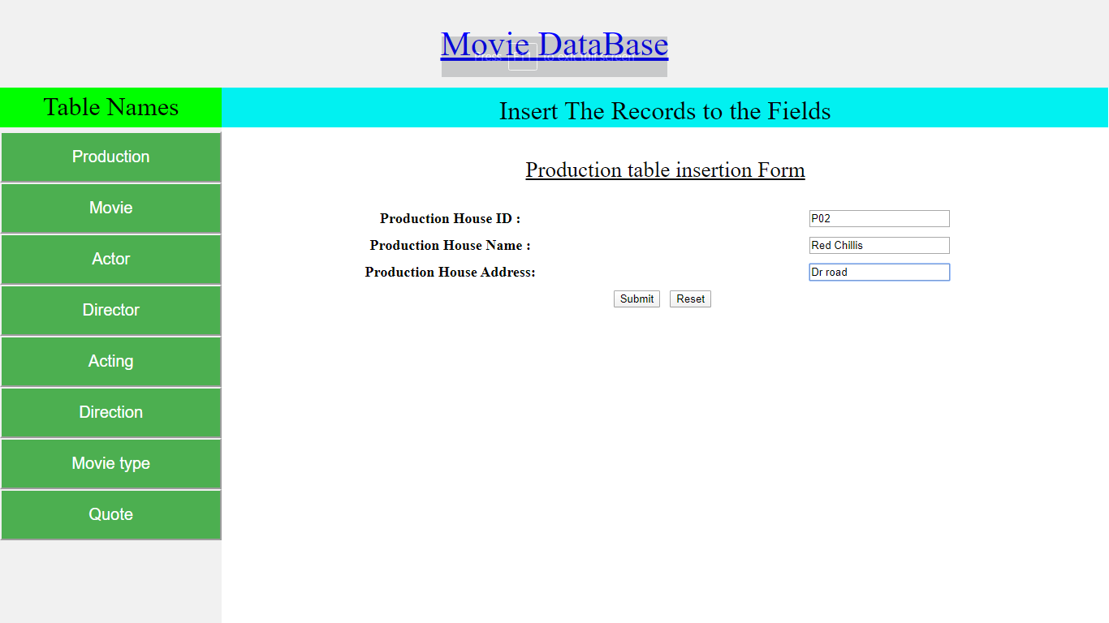

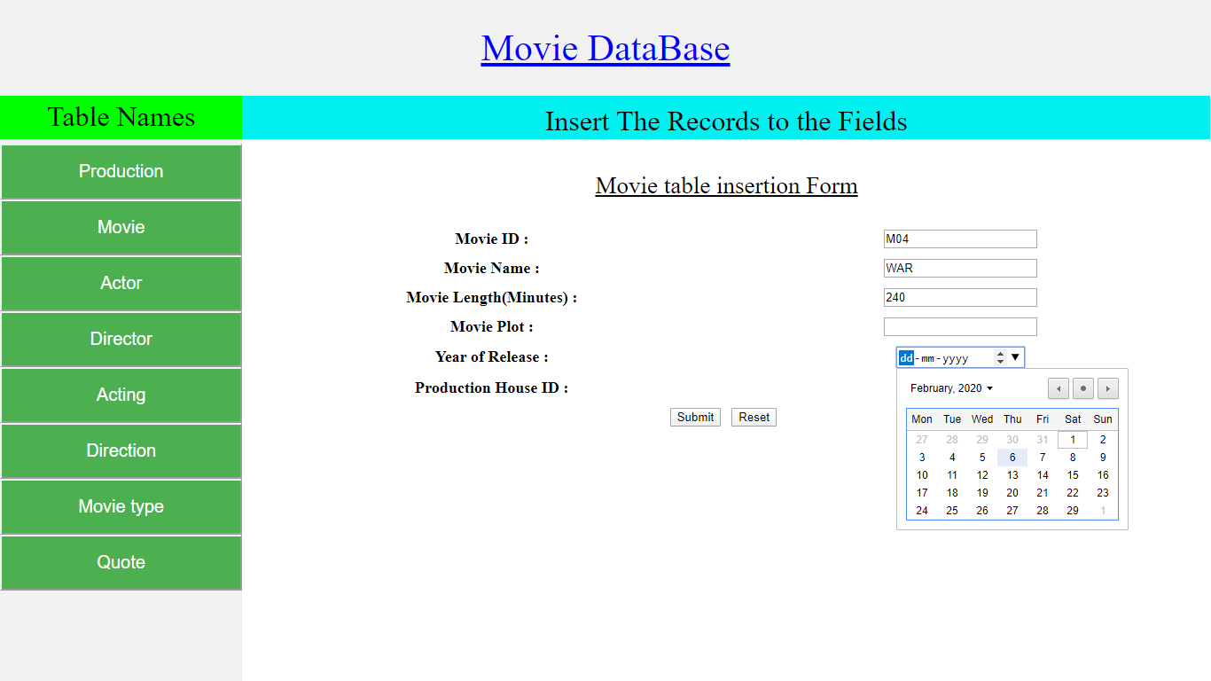

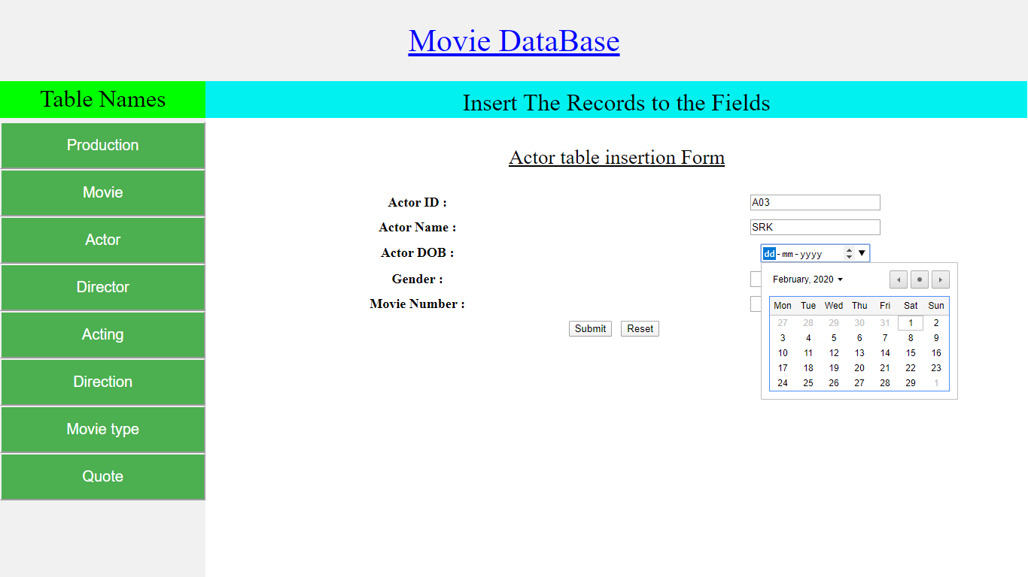

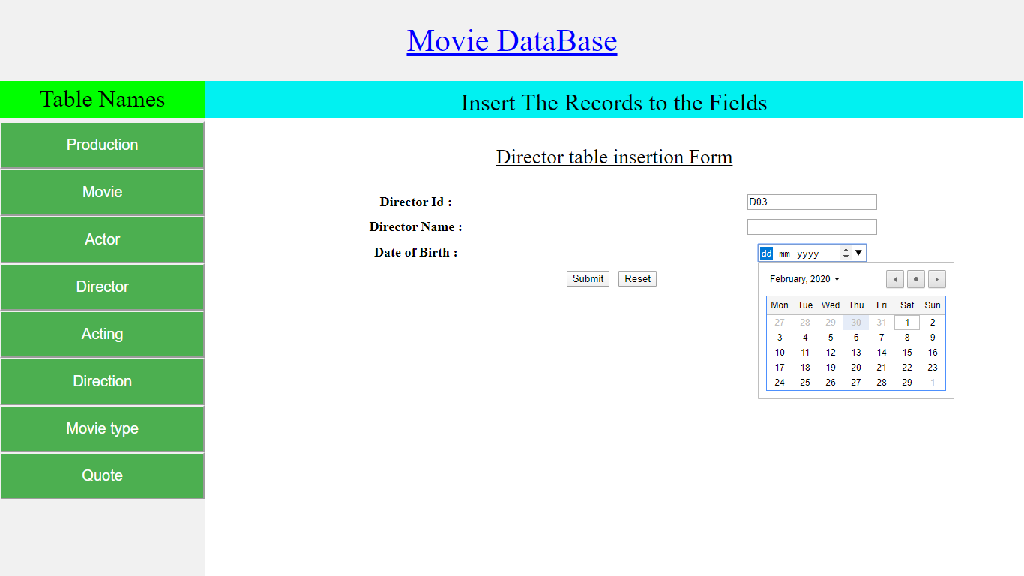

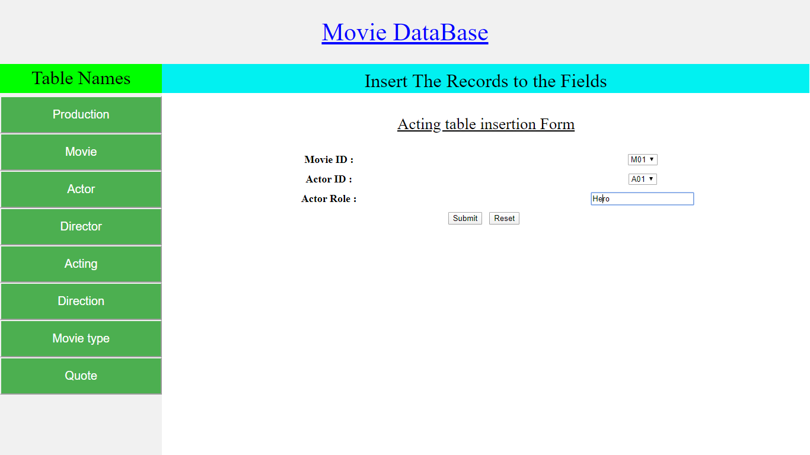

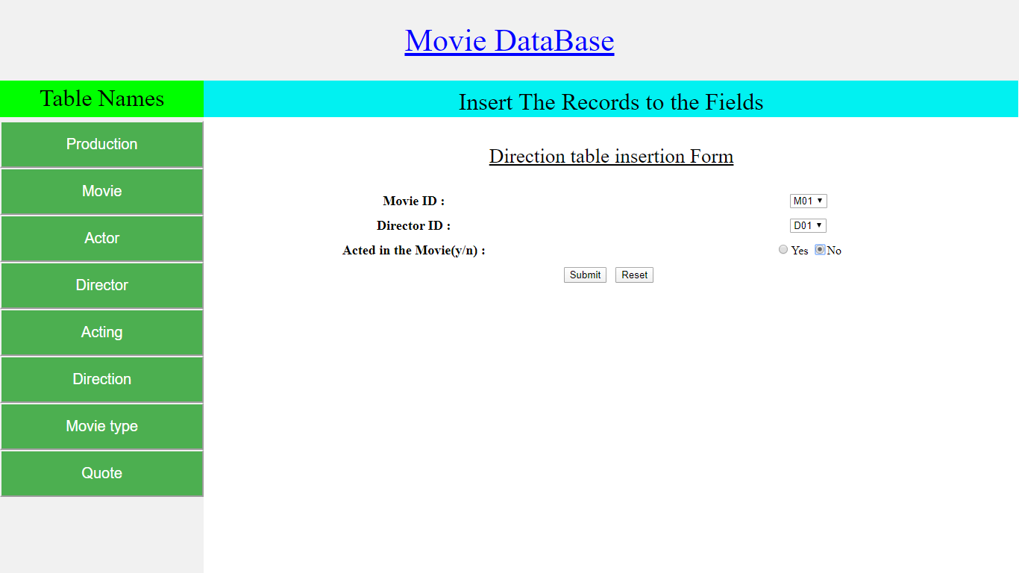

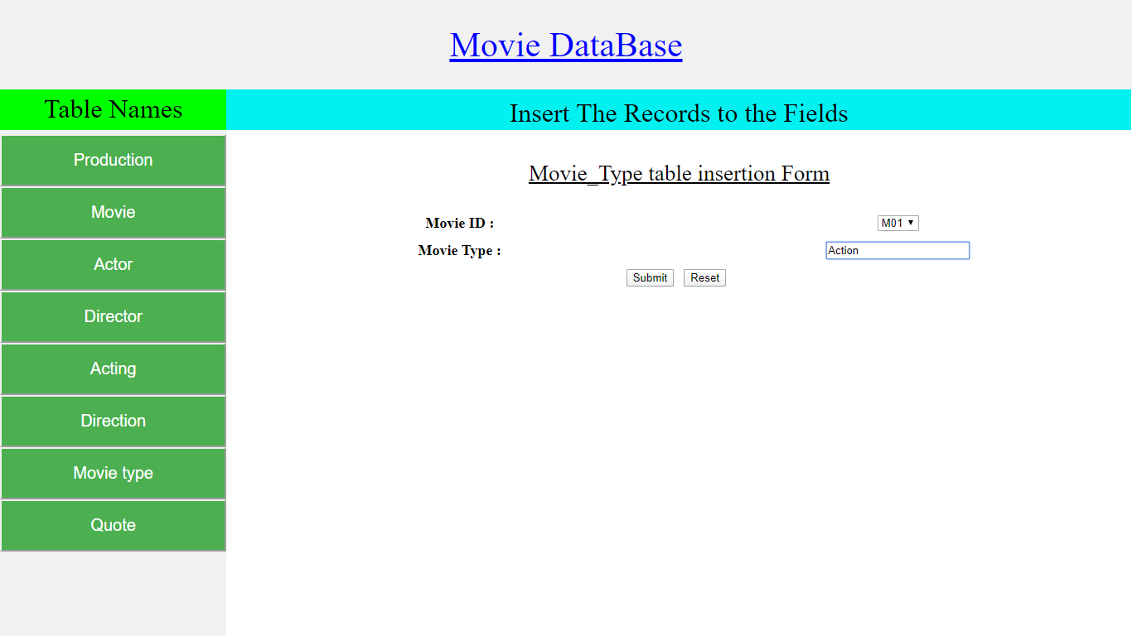

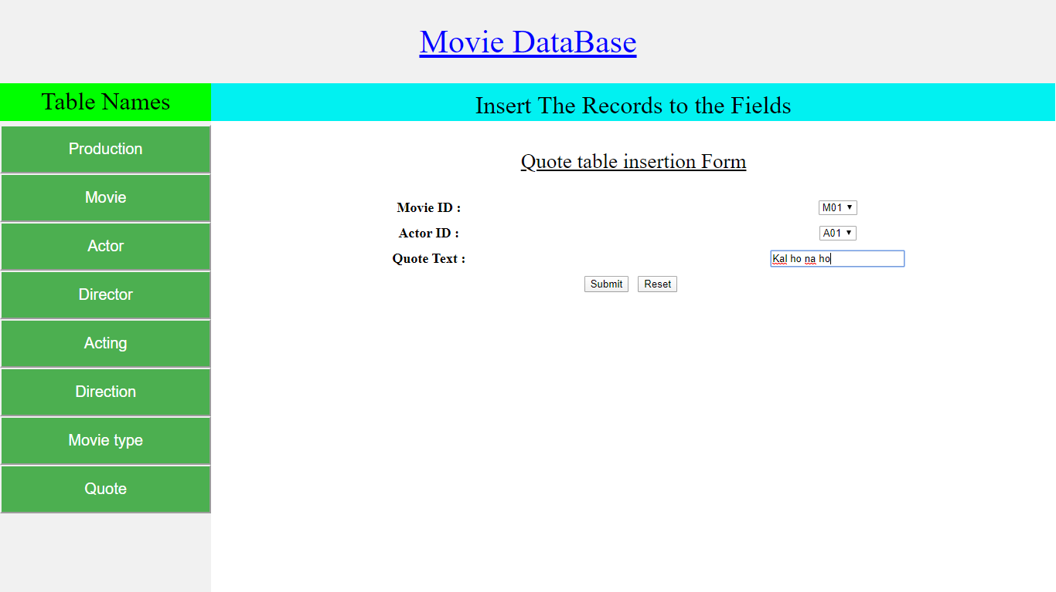

**Report Page View :**

